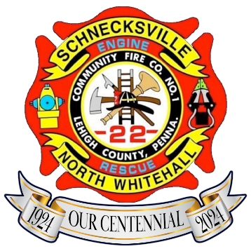
SCHNECKSVILLE FIRE CO

ALL YOU CAN EAT

BREAKFAST

Join us Sunday, October 25th
serving from 8 am – 12:00 noon

MENU
Ham ~ Sausage ~ Bacon ~ Cream Chip Beef (SOS)
Eggs – Any way you like ‘em including OMELETTES!
Home Fries ~ Pancakes ~ Toast
Coffee ~ Tea ~ Orange Juice ~ Hot Chocolate

NEW: MIMOSAS (separate cost & must 21 + Older)

COST

Adult - $13.00

Child (5 to 12) - $7.00 & Child (under 5) – Free

ALL PROCEEDS BENEFIT OUR VOLUNTEER FIREFIGHTERS

